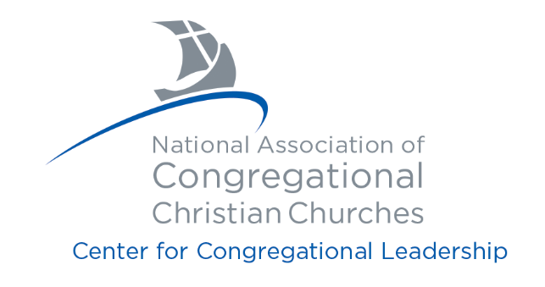

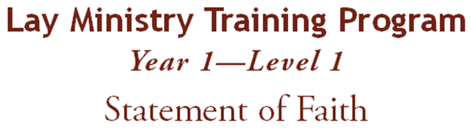
Prepare your statement of belief including your definition of the following: Bible, God, Jesus, resurrection, man and sin, Holy Spirit, salvation, the Church. Support your statement with Biblical scripture. Email this document to pollybodjanac@gmail.com

